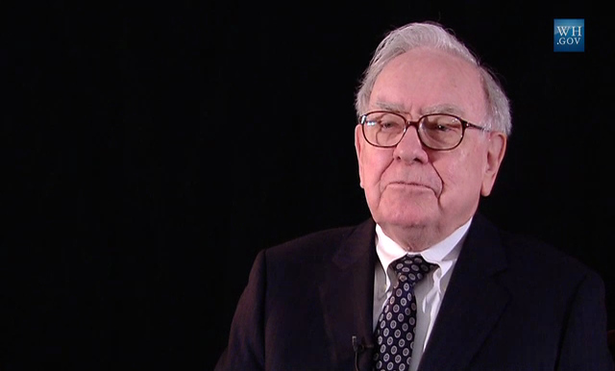
Image via Wikimedia Commons

Warren Buffet bashes cryptocurrencies, admits to knowing “nothing about them”

Dire predictions - but are they well-founded?

The world of cryptocurrency is as fascinating to some as it is confusing and even frightening to others. The new technology not only represents a revolutionary method of transferring money and doing business, but a major shift in the role of money in global society as a whole. It’s something that no doubt every government in the world has had to sit down and have a very serious conversation about, with decentralized currencies placing more power into the hands of the public and limiting the control that banks and legal authorities have over finance. With China freezing Bitcoin transactions in 2017 and South Korea now considering the same move, cryptocurrencies has those most in control of money running scared – and governments aren’t the only ones.

In a January 10th interview with CNBC, renowned investment giant Warren Buffet claimed that the writing was on the wall for cryptocurrencies, saying that they would “come to a bad end” in the near future. Naturally, his comments caused unrest in the cryptosphere with many taking to Twitter to voice their outrage and concern, making it a divisive issue among the community.
A keen-eyed Reddit user pointed out that Warren Buffet still uses a flip phone, as seen in this Yahoo News video at 24 seconds, an indication that despite Buffet’s legendary success on the stock market, he may not be the most qualified person to comment on a developing technology beyond the understanding of the general public.

Buffet himself went on to fuel that argument in the same interview by admitting that he didn’t understand cryptocurrencies at all. When asked if he would be investing in crypto himself, he responded:
“Why in the world should I take a long or short position with something I don’t know anything about… But I do think what’s going on will definitely come to a bad ending.”

Buffet didn’t seem to have any justification for his opinion beyond a gut feeling, and didn’t elaborate further on his predictions. Perhaps he has genuine reasons for his distrust of the world’s newest monetary system. On the other hand, it isn’t difficult to imagine that someone who once dominated the financial world doesn’t appreciate being out of the loop. Vague and perhaps ill-informed as his comments may be, the condemnation of cryptocurrency from such an influential figure in the finance world could well have a major impact on the market as Buffet acolytes fly the coop and sell their assets.

The notorious FUD (fear, uncertainty, and doubt) that has already been dished out from the talks taking place in the South Korean government is already making itself felt out on the high seas of the market today, making it difficult to say what effect Buffet’s comments have had on the community. However, at a time when FUD are already in no short supply, the statement criticizing cryptocurrency from one of the richest men on the planet is sure to hurt more than it helps over the coming days.

